AIr quality monitoring in madurAI

INTRODUCTION
India is one of the ten most industrialized nations in the world, with more rapid advancement in industrialization. The most trending ill effect, we are going through is air pollution (Tuticorin more air polluted area reported by WHO). The important aspect is to predict the quality of air. The reason, why we are giving importance to this type of use case is to give awareness about contaminated air to the public. Now we are running towards the mission of “SWACHH BHARATH”, which became our motivation for a clean city.

ABSTRACT
Quality of air is more suspectable these days. The air quality control gas sensor MQ135 along with controller (Arduino or Raspberry pi) is used to predict the quality of air. The pollutant dataset is created with the values obtained from predicted air quality. Now the dataset is helpful in designing a graph based on obtained values. The graph denotes the increment or decrement of the air quality in the sensed area.
Then the mobile app is created for predicting air quality, which pops as a notification in mobile phones as soon as we enter into a new location. Using data mining tools and techniques of artificial intelligence like artificial neural networks to forecast the air pollutants namely SO2, NOx and RSPM in the monitored locations. Using Machine learning, the previous datas collected, are analysed and the medical precautions are recommended to the user according to the age mentioned by the user.

PROBLEM STATEMENT
Air pollution is booming to be the most spoken topic of today’s day. Finding whether the air is polluted or not polluted and precautions are recommended with artificial intelligence, Machine learning.
RELATED WORKS
“Modeling and analysis of ozone concentration by artificial intelligent techniques for estimating air quality”
-Osman Taylan
The idea proposed is High ozone concentration is an important cause of air pollution mainly due to its role in the greenhouse gas emission. Ozone is produced by photochemical processes which contain nitrogen oxides and volatile organic compounds in the lower atmospheric level. Therefore, monitoring and controlling the quality of air in the urban environment is very important due to the public healthcare.
Algorithm:
They used multiple linear regression (MLR) approaches in the modeling of ozone concentration level to estimate the pollution level.
Model:
As an AI technique, artificial neural network(ANN) are simulated from mathematical models of human neural systems to train raw data, generalize a network structure, test new associations of functional relations, and/or model are all life problem. For this reason, ANNs are used widely for forecasting and managing the multi-disciplinary data. ANN can use environmental data to produce a suitable rule based system and estimate the level of ozone for the given factors.
Reference table:
The error of training, and checking data of ANFIS(adaptive neuro-fuzzy inference system) which is a kind of artificial neural network model outcomes vs actual process outcomes.

Observations | Actual outcomes | Training data | Error (%) | Checking data | Error (%)
1 | 47 | 48 | −2.13 | 46 | 2.12
2 | 21 | 21 | 0.00 | 22 | -4.76
3 | 25 | 26 | −4.00 | 25 | 0.00
4 | 54 | 53 | 1.85 | 55 | -1.85

OBJECTIVE
To offer scientific analysis of pollution data. And to identify the Air Quality Index (AQI) based on the predictions of the air pollutants (MPCB and TNPCB etc.. data repository gives the details about pollutant data). To adapt methods from machine learning and data mining of spatial data and apply them to pollution data analysis. To convey remedies through mobile app.

The eight ambient air quality monitoring stations in Chennai are:

S.no | Station location | Land use zone/area
1 | Kathivakkam | Industrial area
2 | Manali | Industrial area
3 | Thiruvottiyur | Industrial area
4 | Kilpauk | Commercial area
5 | Thiyagaraya nagar | Commercial area
6 | Nungampakkam | Commercial area
7 | Anna nagar | Residential area
8 | Adayar | Residential area

By the same way the ambient air quality monitoring must also be done in Madurai also.

PROPOSED METHODOLOGY
Our idea is to predict the safe zone using mobile app and if it indicates the danger zone (red), the precautions is recommended to user. This is made possible by sensors, aurdino and pollutant dataset.
- By using SIEMEN’S air pollution forecasting software we can predict the level of air pollution at 150 locations with the error rate less than 10%.

S.no | City & Location | Category | Annual Average concentrations of Air Pollutants in µg/m³
S.no | City & Location | Category | SO₂ |  |  |  | NO₂ |  |  | RSPM
S.no | City & Location | Category | Max | Min |  | Avg | Max | Min | Avg | Max | Min | Avg
1 | CHENNAI
a) | Kathivakkam | Industrial | 18 |  | 10 | 13 | 24 | 12 | 14 | 93 | 27 | 49
b) | Manali | Industrial | 19 |  | 10 | 14 | 23 | 13 | 17 | 79 | 17 | 43
c) | Thirvottiyur | Industrial | 17 |  | 10 | 13 | 22 | 12 | 17 | 73 | 25 | 44
d) | Anna Nagar | Residential | 26 |  | 9 | 13 | 41 | 13 | 19 | 250 | 28 | 91
e) | Adyar | Residential | 18 |  | 8 | 12 | 22 | 11 | 16 | 80 | 23 | 44
f) | Kilpauk | Commercial (Traffic-intersection) | 32 |  | 9 | 15 | 32 | 13 | 20 | 147 | 29 | 79
g) | Thiyagarayanagar | Commercial (Traffic-intersection) | 28 |  | 11 | 15 | 37 | 14 | 23 | 244 | 38 | 94
h) | Nungambakkam | Commercial (Traffic-intersection) | 32 |  | 10 | 15 | 44 | 13 | 21 | 263 | 35 | 98
2 | COIMBATORE
a) | DCO | Mixed | 9 |  | 4 | 4 | 40 | 17 | 25 | 114 | 8 | 45
b) | Pooniyaraja  Puram | Residential | 4 |  | 4 | 4 | 32 | 16 | 23 | 123 | 16 | 47
C) | SIDCO | Industrial | 8 |  | 4 | 4 | 52 | 20 | 27 | 122 | 16 | 52
3 | THOOTHUKUDI
a) | Raja Agencies | Industrial | 20 |  | 10 | 16 | 29 | 14 | 24 | 663 | 30 | 190
b) | AVM Buildings | Mixed | 14 |  | 6 | 11 | 18 | 9 | 15 | 475 | 16 | 91
C) | SIPCOT | Industrial | 19 |  | 8 | 16 | 29 | 11 | 23 | 383 | 28 | 118
4 | MADURAI
a) | M/S Susee Cars & Trucks (p) Ltd., | Industrial | 21 |  | 10 | 15 | 48 | 14 | 23 | 128 | 31 | 63
b) | Madurai Corporation Offices (SZ) | Mixed | 23 |  | 9 | 16 | 48 | 18 | 27 | 119 | 36 | 79
C) | Highways project Buildings | Residential | 15 |  | 8 | 10 | 36 | 12 | 21 | 113 | 22 | 53

TECHNOLOGY STACK

Hardware Requirements :
MQ135 Air quality sensor
Arduino Microprocessor
Software Requirements :
Front-end : React Native (Android/iOS)
Back-end : Node-js
Database : Firebase
API : Data scrapper

REACT NATIVE:
It is easy to use because it has a wide range of sample application. Uses the same logic whether running on ios, android or HTML5 web app. It is scalable and secure as it is built on PUBNUB’s (realtime chat app powered by flexible API’s. They work across web, ios, android)

NODE-JS:
The retrieval time is less when compared to php and the scalability is more when we use Node-js

FIREBASE:
Dynamically updating the database is more helpful when using Firebase, instead of MySQL.

DATA SCRAPPER:
It is a computer software technique for extracting information from websites. This technique mostly focuses on transformation of unstructed data to structured data

FEATURES AND SCOPE OF PROJECT
Features:
Maintaining the quality of air will be challenging always, so there will a good scope for this concept. This project comprises of Artificial Intelligence , IoT and Data analytics, so even when one concept’s growth decreases other emerges to be booming.

Scope:
Air pollution is a vast field to get involved in. There are numerous specializations as air quality assessment, pollution monitoring, air pollution control, air quality data analysis. Recent area of interests is aerosol and environment, climate change and its impact, global warming, etc. Pollution monitoring and control is always an extensive area for research. There is always a requirement for modification of existing equipment and methodologies.

BLOCK DIAGRAM

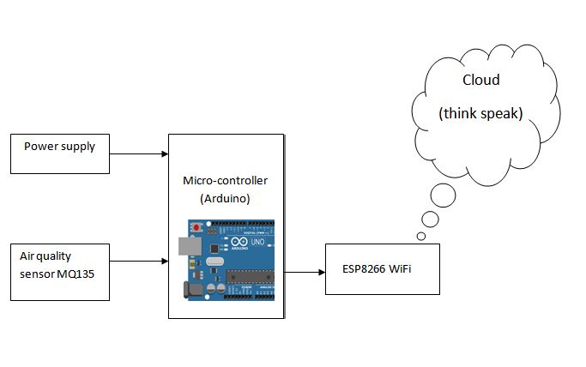

EXPECTED OUTCOME

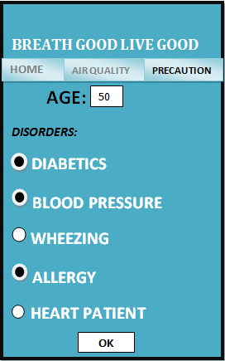

CONCLUSION AND FUTURE ENHANCEMENT
As a service for the environment and human life we have done this project for the concept of “GREEN CITY” and to gift our future generation a clean environment. In future we can implement this project by providing information needed to minimize pollution peaks, thus improving the quality of life.

Submitted by,

J.SHOBIKA  shobikajayaraman@gmail.com  KLNCE | N.H.SARUMATHI  sarumathinh@gmail.com  KLNCE | P.SAROJA  sarorajalakshmi@gmail.com  KLNCE

